**1.Deploying Website on AWS EC2 instances**

Deploying a website on an AWS EC2 instance involves several steps, including setting up the EC2 instance, installing a web server, and uploading your website files. Here is a detailed, step-by-step guide for deploying a website on an AWS EC2 instance:

Step 1:

1. In AWS console, search VPC.

2. In VPC dashboard , you will get my VPC’s and click on myvpc’s.

3. Click on create VPC. Select resource to create as vpc only.

4. Give name as dhyan-vpc and IPv4 CIDR as 10.0.0.0/16.

5. Then click on create VPC.

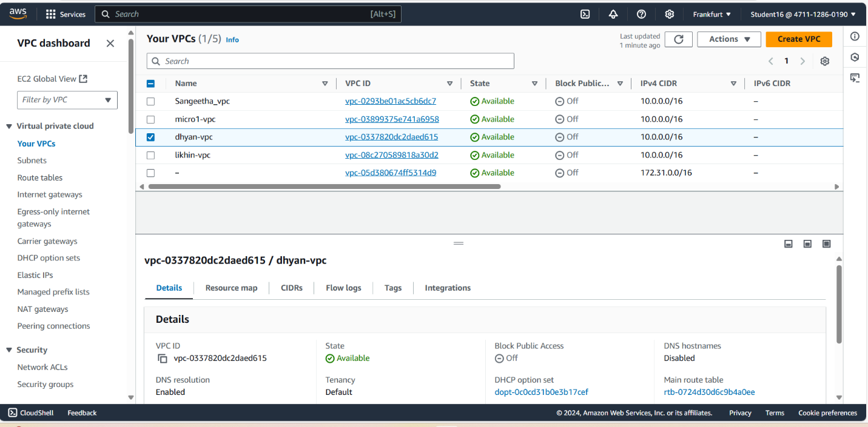

Step 2: create internet gateways

1. In VPC dashboard, click on Internet Gateway.

2. To create Internet gateway, click on create Internet Gateway.

3. Then give name as dhyan-igw and click on create Internet Gateway.

4. Your internet Gateway is created.

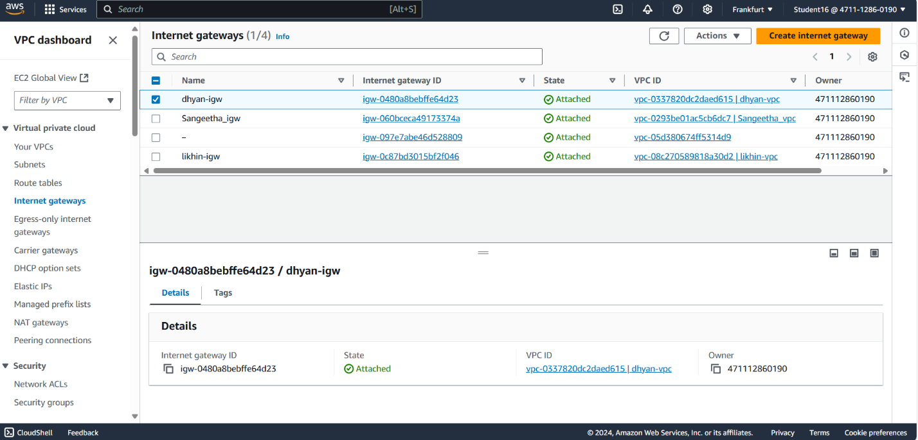

Step 3: create subnet

Step for dhyansub-1:

1. To create subnet, go to VPC dashboard under virtual private cloud, click on subnet.

2. Select the vpc you have already created and in subnet setting, give subnet name as dhyansub-1 .

3. Then choose availability zone as region you have selected before creating the vpc and IPv4 subnet CIDR block as 10.0.1.0/24.

4. Then create one more subnet as following subnet but give name as dhyansub-2 and then choose availability zone and IPv4 subnet CIDR block as 10.0.2.0/24

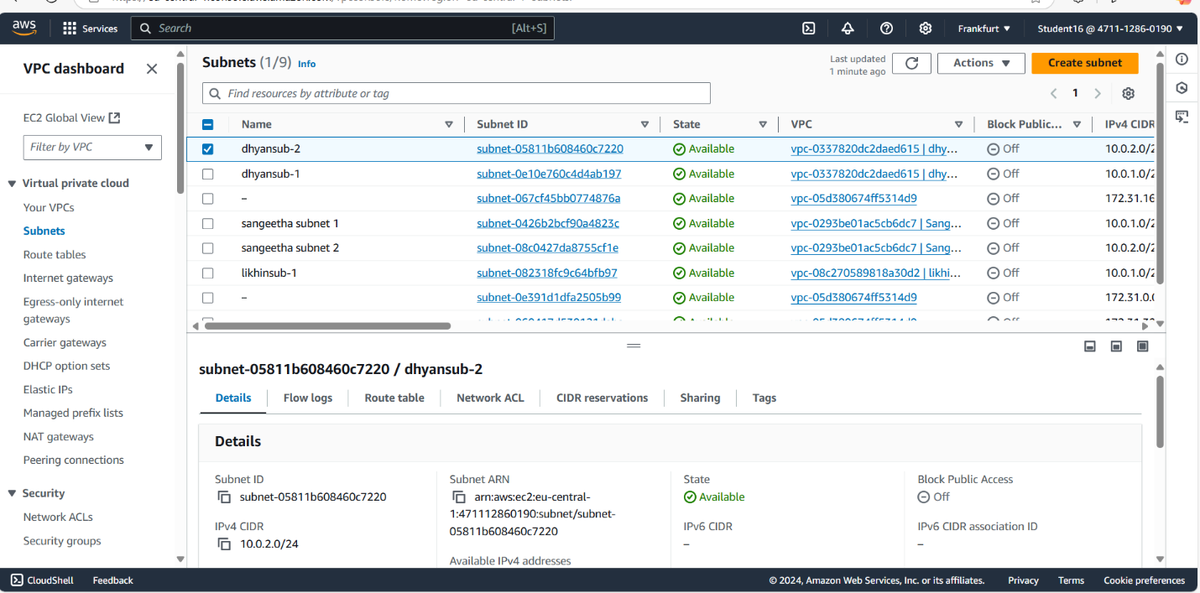

Step 4: create route tables

Steps : 1. To create Route table, click on create route table.

2. In route table setting, give route table name as public-RT and select vpc that is created.

3. Then click on create route table.

4. After route table is created, go to routes and click on edit route and then click on add route.

5. Then in destination, select 0.0.0.0/0 as destination and target as Internet Gateways .

6. After selecting internet gateway, it allows to select the igw- and select the internet gateway that is created by you.

7. At last click on save changes.

8. Then go to subnet association and click on edit subnet association.

9. Select the subnet you have created and click on save changes.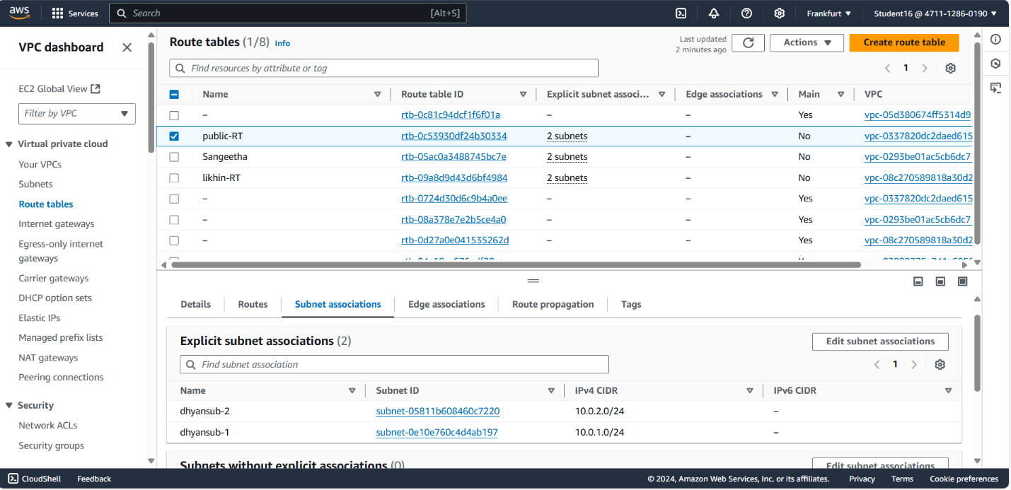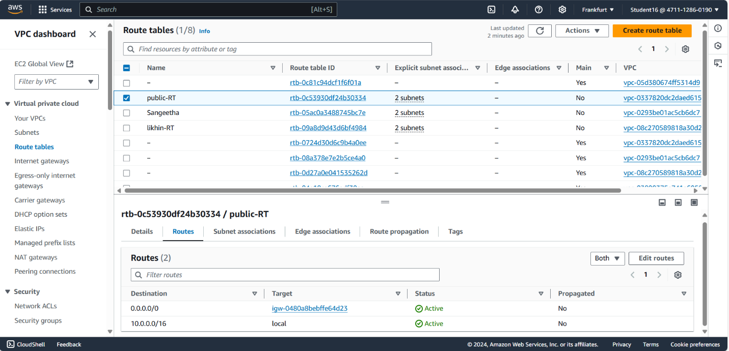

EC2 Instance: Steps:

1. Go to EC2 in AWS console and click on instances.

2. Click on launch instance and give the name for the instances as dhyan16.

3. After giving name to instances, select application and OS Images as Amazon Linux and instances type as t2.micro .

4. In keypair, click on create keypair and give keypair name as dhyan-keypair and click on create keypair. The keypair is created.

5. Then in network setting, click edit. Select vpc and subnet and also assign public IP as enable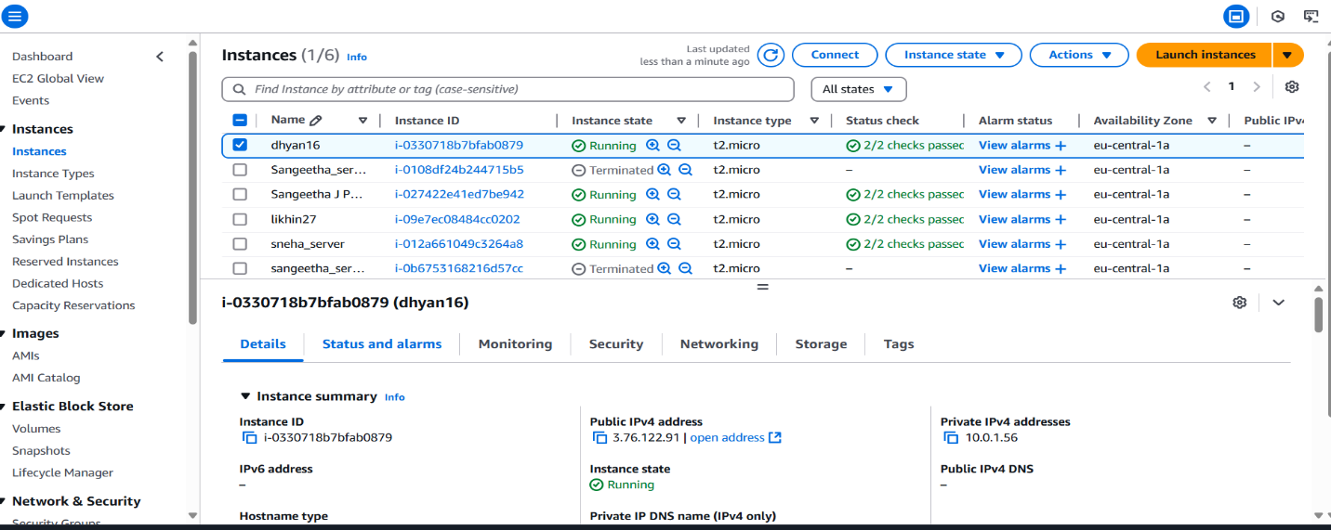

Connection: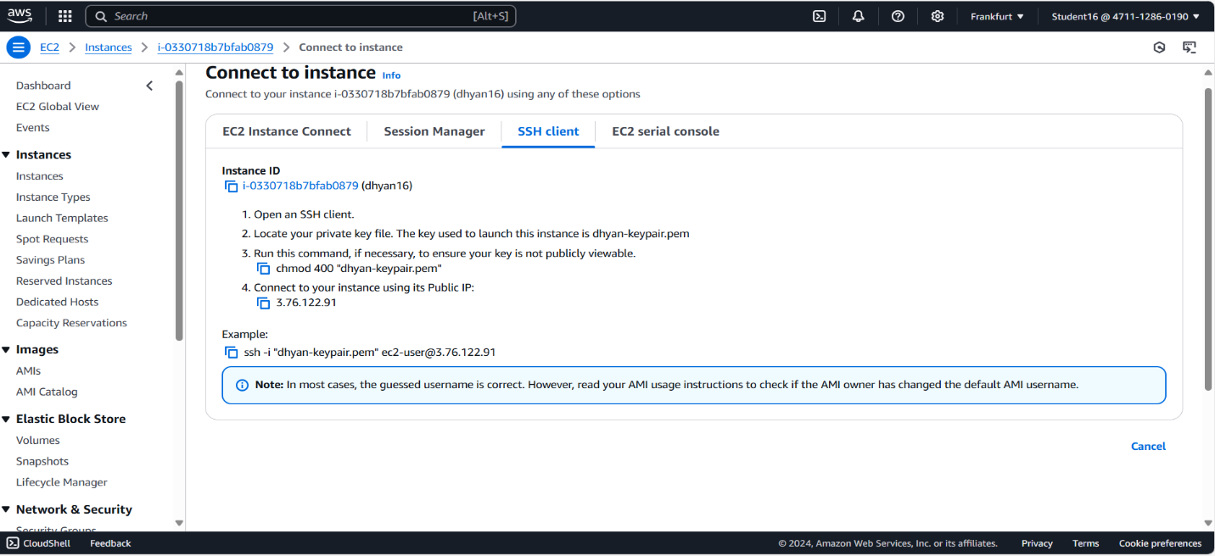

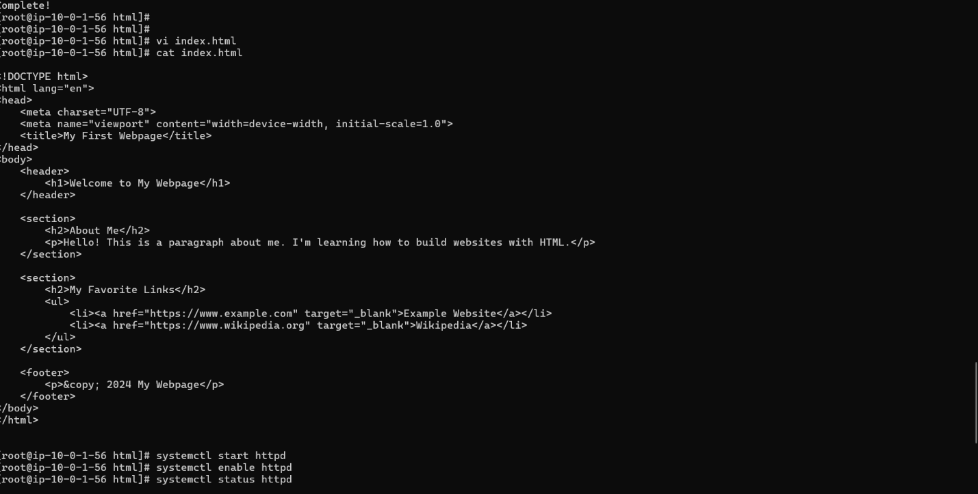

final Result:

